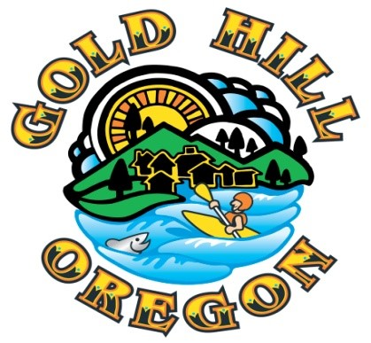

City Manager Report
January 9, 2022

- Elected Officials Handbook – Staff has assembled a binder for each Elected Official to use as reference for the upcoming year. The binder contains three documents that have been previously mentioned and likely familiar to the existing Council. The documents are:
- League of Oregon Cities (LOC) publication – “Local Government, The Basics”
- Gold Hill Resolution 12-R-11 - Council Rules
- Gold Hill City Charter
In addition to having these three resource documents, the binder can be used for Council meeting packets and other Council related business. If you have other documents you would like printed copies of for this binder, please let me know.
- City Website – The new website will be launched in the coming days. The data was moved from the prior website so there will be some additional time spent to re-organize that data, add new data and add as much to the calendar for 2023 as possible in the coming weeks. We will also be publicizing the website’s subscription tool which allows interested community members to sign up and automatically receive email updates when new information (news, calendar events and Council business primarily) is posted to the website.
3. DEQ TMDL Annual Report– The City has an approved five year action plan with DEQ and is required to submit an annual report on implementation activities completed each fiscal year in support and furtherance of the agreed upon actions. Our FY2020-21 report was submitted by the November 1, 2022 due date and was accepted by DEQ on December 27, 2002.
4. Oregon Health Authority (OHA) – 2022 Water System Survey Report– OHA staff recently completed a required three year survey/assessment of the City’s water system, both treatment and delivery/distribution. A number of items were included in the final report for follow-up, including public noticing for water system customer education that will be posted to the City website. Several other items relate to needed infrastructure capital projects that will be discussed as part of the FY 2023-24 budget process.
Our water treatment plant contractor is Southern Oregon Water Technologies, with Michael Bollweg (Owner) and Debbie Bunker as our primary operators and invaluable advisors keeping the water treatment plant operating as we look to make improvements to the infrastructure to maintain water quality and treatment volume necessary to serve the community.
5. ODOT – Small Cities Allocation (SCA) Grant - The City received grant funding in the most recent cycle of funding opportunities from the ODOT-SCA program. The grant totals $220,775 for surface improvement projects including:
- Jacoby St between 5th and 6th
- 5th Av between Lafyette and Norris
- Riverside/Chavner Av (road surface expansion at east end curve)
- Beeman St between 4th and 5th
- Estramado St between 1st and 2nd

