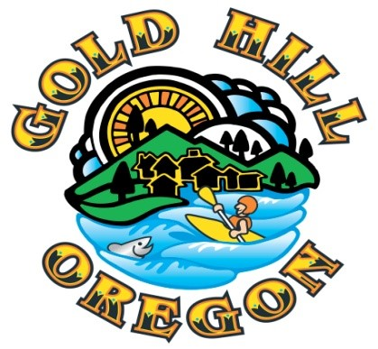

City Manager Report
December 19, 2022

- Fuels Reduction and Vegetation Management for 2023 – With support and coordination from the Parks Advisory Committee (PAC), City staff is working with several entities to partner with to accomplish fuels reduction and vegetation management in three primary areas: Sports Park, Beach Park and City owned property at the reservoir. Initial meetings will be occurring in December and January with Oregon Department of Forestry (ODF), Lomakatsi Restoration, Fire District 3 and the Cascade Relief Team.
The objective is to coordinate as much as possible with already planned fuels reduction work in the area to reduce costs, take advantage of grant funds other agencies have already received and allow our staff to stay ahead of the routine vegetation management prior to fire season stopping that work.
2. Municipal Code Update Project – With the benefit of a Department of Land, Conservation & Development (DLCD) grant of $25,000, our contract land use planning staff at RVCOG has been working with the Planning Commission to review and update the Municipal Code with a focus on the land use section of the code. While the Commission is making great progress, the project is significant and will likely require that some desired updates be tagged as “phase II” items in order to meet the grant timelines. The grant also calls for public engagement on the proposed changes prior to the scheduling of a public hearing for the adoption of the proposed Code revisions. This will be included in the 2023 annual calendar discussion at a future Council meeting.
3. Wastewater Treatment Plant Funding Update – City Engineer Dan Scalas and myself attended a Regional Solutions Team meeting as the first step in requesting funding for the new wastewater treatment facility. The Regional Solutions team is comprised of a regional coordinator and staff members from all of the relevant state agencies including DEQ, Business Oregon/IFA, DLCD, ODOT, DSL, ODFW. The focus of the meeting was preparing for the one-stop meeting, which is the formal request process for funding. Topics also discussed with the regional solutions team included a number of water treatment plant and distribution system upgrade needs as well as storm water infrastructure needs. The One-Stop meeting has not yet been scheduled but is anticipated to occur in early to mid January.
4. Jackson County Sheriff Office Crime Statistics Report – Attached is a recent quarterly comparison report I requested and received from Sheriff Sickler’s Office. The City should now be on the distribution list to receive this report each quarter.
I highlighted three categories where the increase was the most significant compared to prior quarters. In my conversation with Sheriff Sickler, he did not indicate any specific concerns or anomalies specific to Gold Hill compared to the other communities they serve.
5. Council Liaison Assignments and Role – In preparation for the Mayoral assignment of liaisons for 2023 coming in January, I wanted to be sure that I had a complete list of local and regional committees, commissions, etc that Councilors have historically been associated with. Below is my initial list:
- Gold Hill Planning Commission
- Gold Hill Parks Advisory Committee (PAC)
- Middle Rogue Metropolitan Planning Organization (MRMPO)
- Rogue Valley Area Commission on Transportation (RVACT)
- Rogue Valley Council of Governments (RVCOG)
- Southern Oregon Regional Economic Development Inc (SOREDI)
- Dept of Environmental Quality (DEQ)
Note: this is specific to our MAO issues, not a general ongoing assignment

Liaison assignments are made by the Mayor. In my experience, the objective is to spread out the workload as evenly as possible/practical among the Council, adjust for individual Councilor schedule constraints and also try to match up the assignments with areas of interest from each Councilor. Meeting frequency and time of day vary between the different committees/commissions. Several are over the lunch hour (and have lunch provided often), many now offer hybrid zoom attendance (not guaranteed) and only the Gold Hill Planning Commission meets in the evening.
The role of the liaison often varies slightly depending on the commission/committee, but in general it is to:
- Representing the Council as a body, provide updates on relevant projects and issues that Gold Hill is working on or has coming up
- Learn about issues locally and regionally that may benefit or affect Gold Hill
- Share what you learn with the rest of Council at regular Council meetings
- Act as an initial point of contact for the Commission/committee to the City

