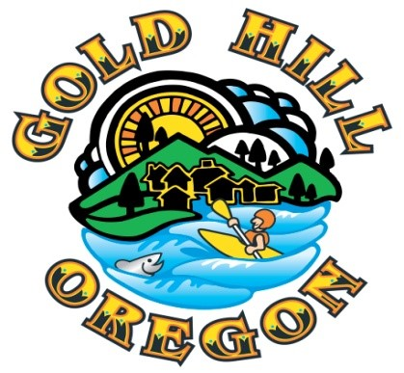

City Manager Report
April 4, 2022

- Jackson County Sheriff’s Office – Public Safety Statistics
Attached are two different types of updated monthly reports for January and February of 2023. The first is Calls for Service by Call Type which tracks monthly call types and also summarizes quarterly and annually. The second is a monthly calls for service report that compares the most current month to the same month in prior years to show longer term trending of each call type.

I have a meeting with the Patrol Lieutenant responsible for patrol activities in the Gold Hill region of Jackson County tomorrow afternoon to follow up on regular statistical reporting and other relevant public safety issues for Gold Hill.

- New Wastewater Treatment Plant/Pipeline Follow-Up
From Council direction at the March 21, 2023 Council meeting, I have had meetings with DEQ staff and Carl Tappert with Rogue Valley Sewer Systems (RVSS) relaying Council’s interest in exploring whether a possibility remains for working with RVSS to pursue becoming a part of the RVSS Service District and constructing a pipeline to convey wastewater from Gold Hill to the regional collection and treatment system.

While additional dialogue and exploration is required, initial conversations have been very positive and there is a pathway to pursue the pipeline should Council want to formally move in that direction. The timeline is tight and I will have a more complete process outlined for Council at the April 18, 2023 Council meeting. This will include a decision by Council to approve a resolution requesting the RVSS Board of Directors to consider/approve putting forward a ballot measure to annex the City of Gold Hill into the RVSS Service District upon a majority vote of the community.

There will also be annexation and franchise agreement documents that will be developed and presented to Council that will outline the process, requirements and responsibilities of each entity should the expansion of the RVSS service district be approved by Gold Hill voters.

- Wastewater Plant Operations RFP Update
Within the discussion of the potential for pursuing the pipeline was a discussion of the possibility of RVSS continuing to provide the operations and maintenance contract with the City rather than continuing to pursue contract negotiations with OEC, the highest ranked bidder to our recent RFP. Initial word from RVSS is that they will consider re-signing/extending the recently terminated contract (we are still in the phase out period of the contract) if the City can provide assurances that it intends to move forward with inclusion into the RVSS service territory and execute the necessary agreements to begin work on the pipeline construction. This assurance will come in the form of the resolution (noted above in item #2) presented in at the April 18, 2023 Council for review, deliberation and decision.
4. Municipal Code Update Project
The Planning Commission has nearly completed their work in reviewing and suggesting deletions, edits and new language to the Gold Hill Municipal Code. We have planned a jointly hosted open house by both the Planning Commission and City Council prior to the April 18 Council meeting for those interested in hearing about the process and the proposed changes. This will be followed by two public hearings for Council to review and approve ordinances that will formally update the Municipal Code. The first reading of the ordinance will be May 2, 2023 and the second reading will be May 16, 2023.

Our contract land use planner from the Rogue Valley Council of Governments, James Shireman has been a major asset to both the Planning Commission and to staff on this project and with our regular land use planning work since he took over for Ryan Nolan last summer. James will be providing much of the staff overview and technical answers along with Planning Commission members at the open house and will co-present with me for each of the two Council public hearings.

5. Fuels Reduction Update
I met with Ian Kassab, Community Risk Reduction Captain with Fire District 3 today and went over existing grant funded opportunities. A major grant application was unsuccessful, but both District 3 and the City of Gold Hill have a grant application awaiting decision with the Oregon State Fire Marshal’s Office that we hope to hear back on within the next two to three weeks.

We also recently signed a memorandum of understanding with Lomakatsi Restoration Project in hopes of utilizing their grants team to find applicable funding for riparian area fuels reduction at both the Sports Park and Beach Park. No new information on funding availability has been determined at this point.

We have tentative word that the Northwest Youth Corps will be back in Gold Hill for some project work this summer and have given them three priority locations for their limited time available in Gold Hill; the area immediately around the water intake at the north end of the Sports Park, the sloped area near residential structures at Beach Park and the immediate area around the water supply reservoir.

