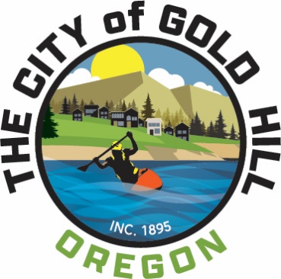

PARKS and RECREATION ADVISORY COMMITTEE
MEETING AGENDA
Monday July 17, 2023, 3:00 PM

Meeting Location: Gold Hill City Hall

- Call to Order/ Roll Call/Pledge of Allegiance

- Agenda Adjustments
Adjustments to the agenda are limited to a change in the order of business to accommodate visitors making presentations or citizens who are attending for the purpose of a single agenda item. Adjustments in the form of additions to the agenda are discouraged because the general public has had no prior notice of their consideration, and therefore interested persons will not have an opportunity to participate. Adjustments in the form of deletions from the agenda may be accomplished here so long as there is disclosure of the reason for the deletion and an indication as to when or if the item will be placed on a future agenda.

- Public Input (5 minutes each max)
- Staff Report/Updates
  - Vegetation Management (All Parks)
  - Powerhouse Design Option Grant Project Update
  - Tennis Court Surface Repair Project
  - Irrigation of main field

- Policy for Memorials, Donations, Gifts in City Parks
- Dardanelles St - Encroachment Permit Application Recommendation
- Splash Park
- Term limits for Parks Advisory Committee
- Other items/reports?
Adjournment
Note: This agenda and the entire agenda packet, including staff reports, referenced documents, resolutions and ordinances are available at the Gold Hill City Hall in advance of each meeting 420 6th Avenue (P.O. Box 308), Gold Hill, OR 97525. Information can also be viewed at www.cityofgoldhill.com

